# ICON FUV

# flatfield

# ICN-FUV_080

## REV - B

# 2015-september-17

As Run on: ____________________________ Date/Time

By: ____________________________ Test Conductor

# Document Revision Record

|  |  |  |  |
| --- | --- | --- | --- |
| **Rev.** | **Date** | **Description of Change** | **Approved By** |
| - | July 7, 2015 | Initial Draft Released |  |
|  | September 17, 2015 | Updates after calibration procedure discussion |  |
|  |  |  |  |

#### DISTRIBUTION LIST

|  |  |
| --- | --- |
| **Name** | **Email** |
| Cathy Chou  Bill Craig  Carl Dobson  Harald Frey  Stu Harris  Claire Poppet  Will Marchant  Stephen Mende  Kodi Rider  Irene Rosen  Chris Scholz  Ellen Taylor | [chouc@ssl.berkeley.edu](mailto:chouc@ssl.berkeley.edu)  [craig@ssl.berkeley.edu](mailto:craig@ssl.berkeley.edu)  [cad@ssl.berkeley.edu](mailto:cad@ssl.berkeley.edu)  [hfrey@ssl.berkeley.edu](mailto:hfrey@ssl.berkeley.edu)  [sharris@ssl.berkeley.edu](mailto:sharris@ssl.berkeley.edu)  [clpoppett@lbl.gov](mailto:clpoppett@lbl.gov)  [marchant@ssl.berkeley.edu](mailto:marchant@ssl.berkeley.edu)  [mende@ssl.berkeley.edu](mailto:mende@ssl.berkeley.edu)  [kodi.rider@ssl.berkeley.edu](mailto:kodi.rider@ssl.berkeley.edu)  [irene@ssl.berkeley.edu](mailto:irene@ssl.berkeley.edu)  [cscholz@ssl.berkeley.edu](mailto:cscholz@ssl.berkeley.edu)  [ertaylor@ssl.berkeley.edu](mailto:ertaylor@ssl.berkeley.edu) |

**TBDs**

|  |  |
| --- | --- |
| **Identifier** | **Description** |
|  |  |
|  |  |
|  |  |

|  |  |
| --- | --- |
| WRITTEN BY Harald Frey DATE 07/JULY/15  APPROVALS  ENG : ________________________ DATE __________  SCI (FUV) : _________________ (SM) DATE __________  PM (FUV): __________________(CC) DATE __________  P/L SE : _____________________(SH) DATE __________  PSE : ______________________ (ET) DATE __________  QA: ________________________(JF) DATE __________ | REVISIONS:  B – September 17, 2015 |
| 1.0 OBJECTIVE, 2.0 APPLICATION, 3.0 DRAWINGS and DOCUMENTS, 4.0 REQUIRED PERSONNEL, 5.0 EQUIPMENT, 6.0 CONFIGURATION, 7.0 SAFETY, 8.0 PROCEDURES, 9.0 ANOMALIES.  APPENDIX A: EMERGENCY SHUTDOWN and BACKOUT STEPS. | |

1. Objective.

This procedure provides the steps to obtain the instrument flatfield of both FUV channels. This procedure will be used at CSL in Belgium with FUV in the 6.5 m vacuum chamber.

The test is similar to the determination of the distortion map but without the diffuser in the beam and data readout through the ICP.

1. Application.

This procedure will be run once at room temperature (RT).

1. Drawings and Documents.

ICN-SYS-TBD ICON Contamination Control Plan

ICN-SYS-TBD ICON Purge Plan

1. Required Personnel.

The following personnel are required to be involved for this procedure:

1. Chris Scholz or representative, Quality Assurance
2. Ellen Taylor or Stu Harris, Project/Payload Systems Engineer
3. Cathy Chou or representative, FUV Instrument Lead
4. Stephen Mende or representative, FUV Instrument Scientist

Record assigned Test Conductor ______________________

Record attending Test Personnel ______________________

______________________

______________________

______________________

______________________

______________________

Only the Project Manager, Project Systems Engineer, Payload Systems Engineer, Assigned Test Conductor or Quality Assurance has the authority to make changes in this procedure during operation if the need arises. At least one of these individuals will be present during the full duration of operations.

1. Equipment.

Instrument GSE:

FUV GSE Hardware (Note Serial Number):

1. Keysight N6700B Power Supply ________________________
2. ICP Communications Emulator (CE) ________________________
3. ITOS Machine, ITOS Version ________________________
4. Engineering Model ICP (Foxtrot) ________________________
5. Keithley ________________________

Harnesses (in addition to Flight Instrument Harness):

1. FUVA- J31 FUV Camera A Data (SWC) __________________
2. FUVA- J32 FUV Camera A Power __________________
3. FUVA- J33 FUV Camera A HV Power Supply __________________
4. FUVA- J34 FUV Camera A HV Arming Plug __________________
5. FUVB- J31 FUV Camera B Data (LWC) __________________
6. FUVB- J32 FUV Camera B Power __________________
7. FUVB- J33 FUV Camera B HV Power Supply __________________
8. FUVB- J34 FUV Camera B HV Arming Plug __________________
9. FUV- J35 FUV Optics Interfaces __________________
10. FUV- J36 FUV Turret Electronics __________________
11. FUV- J37 FUV Turret Electronics Output __________________
12. FUV- J38 FUV Turret Arming Plug __________________
13. Configurations.

FUV is fully integrated. UV alignment is finished and all mirrors and grating are staked and in final positions. Communication is EM ICP to ITOS machine for power, commanding, and data readout. Test plugs and equipment are installed:

* FUV SW Camera FULL HV Enabling Plug is installed
* FUV LW Camera FULL HV Enabling Plug is installed
* FUV Door Lift Assembly is installed (if necessary)
* FUV Turret Counterbalance is installed (if necessary)
* FUV Turret Arming Plug is installed
* Turret at 0 degrees with door opened

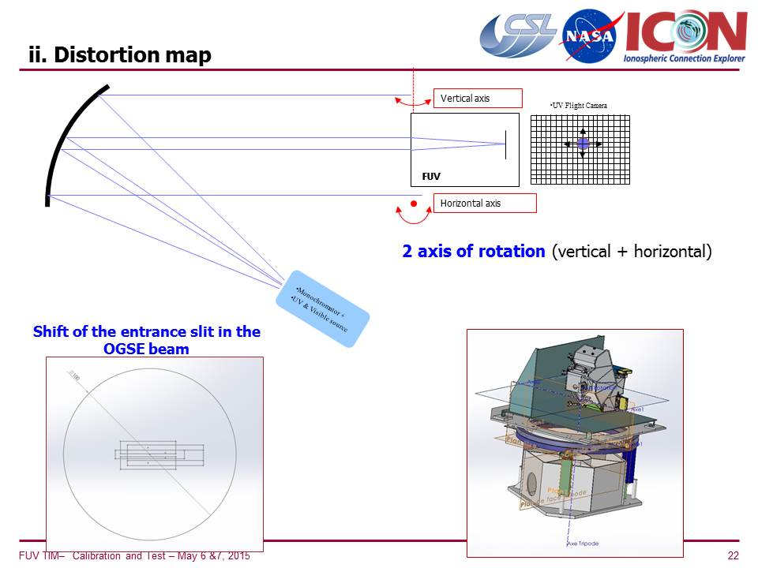

Figure 1: Schematic of test setup

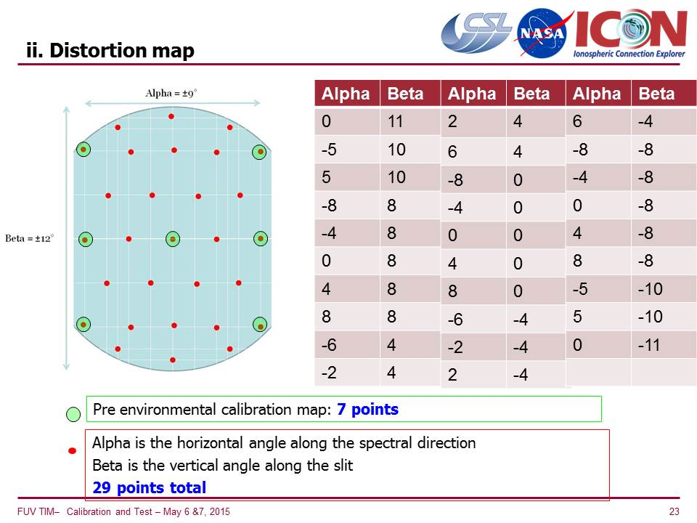

Figure 2: Field angles for the determination of the FUV instrument flatfield

Note deviations from above configuration: ________________________________________________________________________________________________________________________________________________________________________________________________________________________________________________________________________________________________________________

Test Conductor Sign-Off on deviations: __________

1. Safety Precautions.

The FUV Instrument should be treated as ESD sensitive, and handled per the requirements listed in IVN-SYS-003 Environmental Requirements Document (ERD).

The FUV Instrument is contamination sensitive, and must be handled with appropriate care. At all times, the payload shall be handled per the requirements listed in ICN-SYS-006 ICON Contamination Control Plan.

All moving operations outside of a clean room will take place with the payload covered with anti-static bagging. The payload will be handled only by personnel wearing attire appropriate for a FED-STD-209 Class 100,000 cleanroom, including gloves. If the payload is double bagged, personnel will not need full cleanroom suits. However, gloves and wrist straps will be required.

The FUV Instruments must be under purge at all times. See ICN-SYS-TBD ICON Purge Plan for purge monitoring and safety precautions.

1. Procedures.
   1. Test Configuration
      1. FUV instrument installed in CSL vacuum chamber with door opened
      2. Proper movability of cradle confirmed
      3. Electric connection through feedthrough confirmed
      4. Communication between ICP and FUV confirmed
      5. Verify Proper FUV Test Configuration

❐ FUV SW Camera FULL HV Enabling Plug is in

❐ FUV LW Camera FULL HV Enabling Plug is in

* + 1. Verify proper vacuum chamber pressure of <10^3 Pa
    2. Start UV source
    3. Tune monochromator to 135.6 nm
    4. Characterize incoming beam with CSL photodiode
    5. Verify computer time is correct and note start time

Start time: _______________________________________

* + 1. Verify cover is open

FUV_cover: ____________________ Required: OPENED

Sign off: _______________________ (TC initials required)

* 1. Note instrument temperature for the record

|  |  |  |  |  |  |
| --- | --- | --- | --- | --- | --- |
| FUV instrument | Temperature at begin of test | Temperature at end of test | OGSE/MGSE | Temperature at begin of test | Temperature at end of test |
| FUVS_Temp1 |  |  |  |  |  |
| FUVS_Temp2 |  |  |  |  |  |
| FUVS_HV_Temp |  |  |  |  |  |
| FUVL_Temp1 |  |  |  |  |  |
| FUVL_Temp2 |  |  |  |  |  |
| FUVL_HV_Temp |  |  |  |  |  |
| FUV_TUR_Temp |  |  |  |  |  |
| FUV_OPT_Temp |  |  |  |  |  |
| FUV_IMG_Temp |  |  |  |  |  |
| FUV_GRAT_Temp |  |  |  |  |  |

* 1. Instrument Payload Power On (Steps 8.3 to 8.5 could potentially get skipped if prior test did not power off FUV, ICP, and SDL PC)
     1.  Execute Section 8.9 in the FUV CPT (ICN-FUV-068) for ICP power on. Attach As-run paper procedure to the appendix. Note FUV CPT revision below

FUV CPT Revision: __________________________________

Sign off: ____________________________ (TC initials required)

* 1. FUV Camera Power Control
     1.  Execute Section 8.10 of the FUV CPT (ICN-FUV-068) for the Camera Power Control. Add notes to attached As-run paper copy of procedure.

FUV CPT Revision: ___________________________

Sign off: ____________________________ (TC initials required)

* 1. FUV High Voltage (HV) On
     1.  Execute Section 8.13 in the FUV CPT (ICN-FUV-068) for FUV High Voltage setup. Attach As-run paper procedure to the appendix. Note FUV CPT Revision used below

FUV CPT Revision: _______________________________

Sign off: ________________________________ (TC initials required)

* 1. SW channel flatfield determination
     1.  Verify Monochromator is set to 135.6 nm
     2.  Characterize incoming beam
     3.  Set up ICP to collect 256x256 pixel images
     4.  Verify that turret is at nominal 0 degrees position
     5.  Verify that cradle is set to normal incidence 0 degrees
     6.  Send command: **IOP_FUV_DUMP_ENG_IMG**  (enter **TDI ID = 0** for A) to capture and readout image to take an integrated picture of 100 frames of 120 msec exposure time and save through ICP with appropriate header information about time, number of frames, cradle position, wavelength, channel,
     7.  Verify appearance of a spot in the SW channel located at approximately the center of the image
     8.  Move cradle to input field positions listed in the table below and repeat step 8.6.6 for each field position. Note the approximate pixel position of the spot center as the detailed analysis will be done later.

|  |  |  |  |  |
| --- | --- | --- | --- | --- |
| **Angle alpha** | **Angle beta** | **Spot X-pixel position** | **Spot Y-pixel position** | **Spot counts** |
| 0 | 0 |  |  |  |
| 0 | +11 |  |  |  |
| -5 | +10 |  |  |  |
| +5 | +10 |  |  |  |
| +8 | +8 |  |  |  |
| +4 | +8 |  |  |  |
| 0 | +8 |  |  |  |
| -4 | +8 |  |  |  |
| -8 | +8 |  |  |  |
| -6 | +4 |  |  |  |
| -2 | +4 |  |  |  |
| +2 | +4 |  |  |  |
| +6 | +4 |  |  |  |
| +8 | 0 |  |  |  |
| +4 | 0 |  |  |  |
| 0 | 0 |  |  |  |
| -4 | 0 |  |  |  |
| -8 | 0 |  |  |  |
| -6 | -4 |  |  |  |
| -2 | -4 |  |  |  |
| +2 | -4 |  |  |  |
| +6 | -4 |  |  |  |
| +8 | -8 |  |  |  |
| +4 | -8 |  |  |  |
| 0 | -8 |  |  |  |
| -4 | -8 |  |  |  |
| -8 | -8 |  |  |  |
| -5 | -10 |  |  |  |
| +5 | -10 |  |  |  |
| 0 | -11 |  |  |  |
| 0 | -12 |  |  |  |
| 0 | +12 |  |  |  |
| -9 | 0 |  |  |  |
| +9 | 0 |  |  |  |
| 0 | 0 |  |  |  |

* 1. LW channel distortion map determination
     1.  Change Monochromator setting to 157 nm
     2.  Characterize incoming beam
     3.  Set up ICP to collect 256x256 pixel images
     4.  Verify that turret is at nominal 0 degrees position
     5.  Verify that cradle is set to normal incidence 0 degrees
     6.  Send command: **IOP_FUV_DUMP_ENG_IMG**  (enter **TDI ID = 1** for B) to capture and readout image to take an integrated picture of 100 frames of 120 msec exposure time and save on SDL PC with appropriate header information about time, number of frames, cradle position, wavelength, channel,
     7.  Verify appearance of a spot in the LW channel located at approximately the center of the image
     8.  Move cradle to input field positions listed in the table below and repeat step 8.7.6 for each field position. Note the approximate pixel position of the spot center as the detailed analysis will be done later

|  |  |  |  |  |
| --- | --- | --- | --- | --- |
| **Angle alpha** | **Angle beta** | **Spot X-pixel position** | **Spot Y-pixel position** | **Spot counts** |
| 0 | 0 |  |  |  |
| 0 | +11 |  |  |  |
| -5 | +10 |  |  |  |
| +5 | +10 |  |  |  |
| +8 | +8 |  |  |  |
| +4 | +8 |  |  |  |
| 0 | +8 |  |  |  |
| -4 | +8 |  |  |  |
| -8 | +8 |  |  |  |
| -6 | +4 |  |  |  |
| -2 | +4 |  |  |  |
| +2 | +4 |  |  |  |
| +6 | +4 |  |  |  |
| +8 | 0 |  |  |  |
| +4 | 0 |  |  |  |
| 0 | 0 |  |  |  |
| -4 | 0 |  |  |  |
| -8 | 0 |  |  |  |
| -6 | -4 |  |  |  |
| -2 | -4 |  |  |  |
| +2 | -4 |  |  |  |
| +6 | -4 |  |  |  |
| +8 | -8 |  |  |  |
| +4 | -8 |  |  |  |
| 0 | -8 |  |  |  |
| -4 | -8 |  |  |  |
| -8 | -8 |  |  |  |
| -5 | -10 |  |  |  |
| +5 | -10 |  |  |  |
| 0 | -11 |  |  |  |
| 0 | -12 |  |  |  |
| 0 | +12 |  |  |  |
| -9 | 0 |  |  |  |
| +9 | 0 |  |  |  |
| 0 | 0 |  |  |  |

* 1. ITOS power down (this step may be skipped if the following calibration procedure “Turret angle post-vide” will be run without interruption)
     1.  Record time of Instrument Power Off __________________________
     2.  Start FUV_OFF
     3.  Start icp_off
     4.  Quit now in prompt
     5.  Foxtrot_cleanup

1. Anomalies.

Note all anomalies that occurred during procedure:

1. Data Review.

QA Signoff: ___________________________________________ date: ______________

PSE Signoff: __________________________________________ date: ______________APPENDIX A: EMERGENCY SHUTDOWN and BACKOUT STEPS

FIRE:

[1] Stop the operation;

[2] Evacuate the area;

[3] Call 911.

EARTHQUAKE (highly unlikely in Belgium, but better have it in place):

[1] Stop the operation;

[2] Engage brakes on the spacecraft dolly;

[3] Evacuate the area.

VACUUM BREACH:

[1] Stop operations

[2] verify that automatic power off occurred else pull the power plug to FUV